*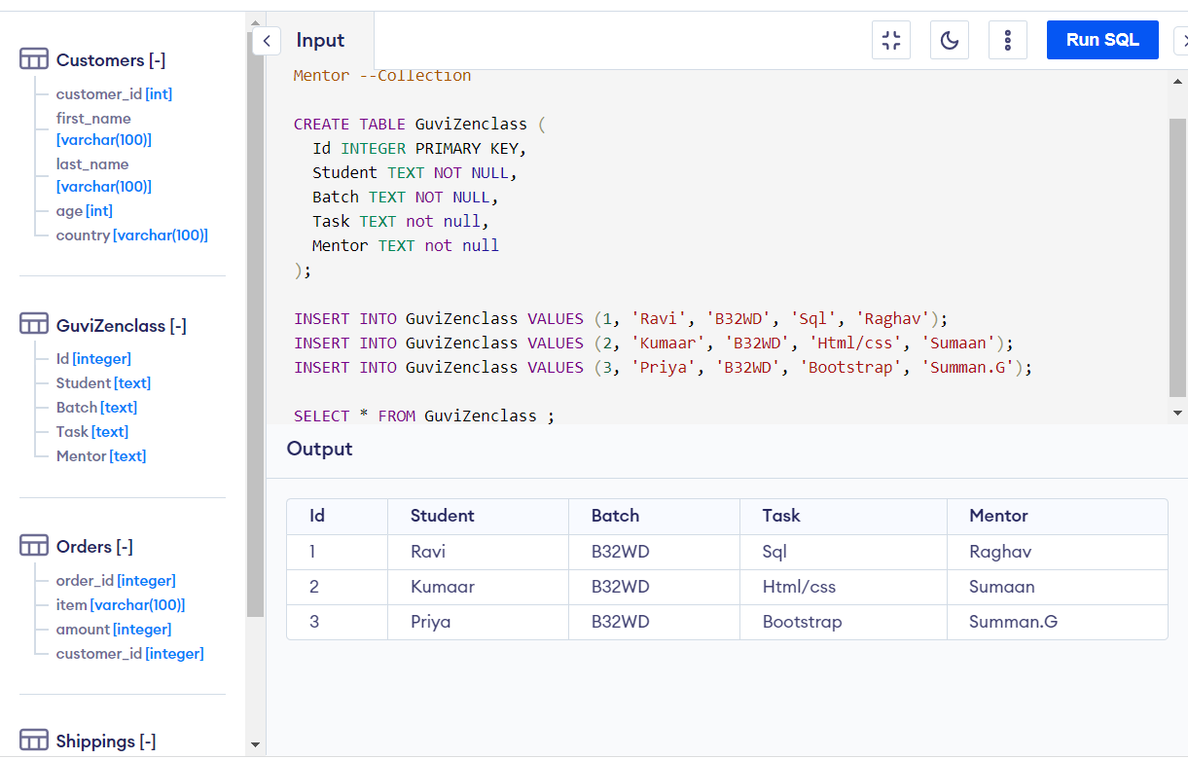*

*Design DB mode*

*l for Guvi Zen class Student Collection Batch Collection Task Collection Mentor Collection*

1. We can insert more details by using INSERT INTO

EXAMPLE:-

INSERT INTO Guvizenclass VALUES (4, 'Jimmy', 'B32WD', 'reactJS', 'Raghav');

--Design DB model for Guvi Zen class Student Collection Batch Collection Task Collection Mentor --Collection

CREATE TABLE GuviZenclass (

Id INTEGER PRIMARY KEY,

Student TEXT NOT NULL,

Batch TEXT NOT NULL,

Task TEXT not null,

Mentor TEXT not null

);

INSERT INTO GuviZenclass VALUES (1, 'Ravi', 'B32WD', 'Sql', 'Raghav');

INSERT INTO GuviZenclass VALUES (2, 'Kumaar', 'B32WD', 'Html/css', 'Sumaan');

INSERT INTO GuviZenclass VALUES (3, 'Priya', 'B32WD', 'Bootstrap', 'Summan.G');

SELECT \* FROM GuviZenclass ;